**Project Design Phase-II Technology Stack (Architecture & Stack)**

|  |  |
| --- | --- |
| Date | 03October 2022 |
| Team ID | PNT2022TMID25247 |
| Project Name | AI based discourse for banking industry |
| Maximum Marks | 4 Marks |

# Technical Architecture:

The Deliverable shall include the architectural diagram as below and the information as per the table1 & table 2

# Example: Order processing during pandemics for offline mode

**Reference: h ttps://novagenio.medium.com/watson-assistant-with-python-flask-chatbots-translation-ibm-options-fd4885ee4bb8**

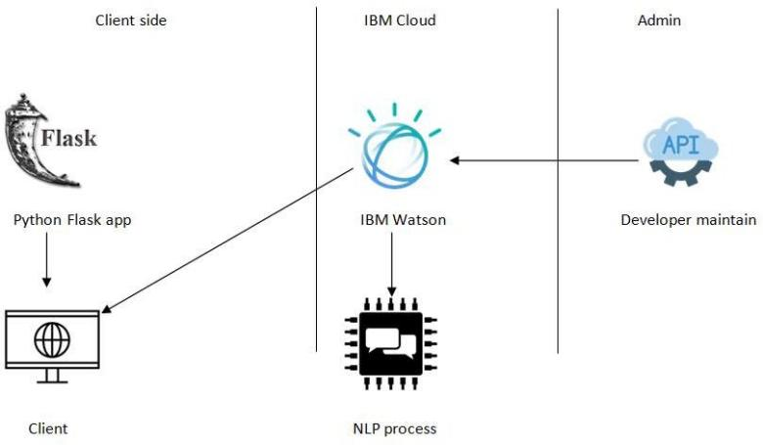

Guidelines:

1. If a customer asked queries after the data to go ibm Watson.
2. After the data will be process to machine understandable form then decision making process to fetch the answer from database.
3. The data will display on through the access medium for client.
4. The flask can be control for the webpage.

**Table-1 : Components & Technologies:**

|  |  |  |  |
| --- | --- | --- | --- |
| **S.No** | **Component** | **Description** | **Technology** |
| 1. | User Interface | How user interacts with application e.g. Web UI, Mobile App, Chatbot etc. | HTML, CSS, |
| 2. | Application Logic-1 | Logic for a process in the application | Python |
| 3. | Application Logic-2 | Logic for a process in the application | IBM Watson Assistant |
| 4. | Cloud Database | Database Service on Cloud | IBM DB2, IBM Cloudant |

**Table-2: Application Characteristics:**

|  |  |  |  |
| --- | --- | --- | --- |
| **S.No** | **Characteristics** | **Description** | **Technology** |
| 1. | Open-Source Frameworks | List the open-source frameworks used | Technology of Opensource framework |
| 2. | Security Implementations | List all the security / access controls implemented, use of firewalls etc. | e.g. SHA-256, Encryptions, IAM Controls, OWASP etc. |
| 3. | Scalable Architecture | Justify the scalability of architecture (3 – tier,  Micro-services) | Technology used |
| 4. | Availability | Justify the availability of application (e.g. use of load balancers, distributed servers etc.) | Technology used |
| 5. | Performance | Design consideration for the performance of the application (number of requests per sec, use of  Cache, use of CDN’s) etc. | Technology used |

**References:**

https://novagenio.medium.com/watson-assistant-with-python-flask-chatbots-translation-ibm-options-fd4885ee4bb8